2024-2025

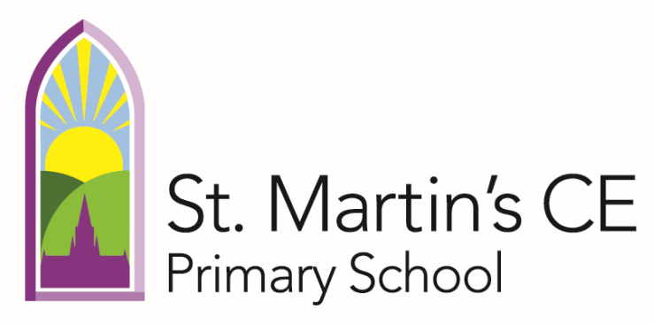

SEND Information Report

Mrs Abbott (SENCo) is responsible for Special Educational Needs and Disabilities (SEND). Mrs Abbott can be contacted on 01722 554300 or sabbott@stmartins.dsat.org.uk

Welcome
St Martin’s C of E (VA) Primary School is a mainstream primary school, which is part of multi-academy trust, called Diocese of Salisbury Academy Trust (DSAT). We are committed to providing a high-equality education for all children in our school. We believe that all children have a common entitlement to a broad and balanced academic and social curriculum which is accessible to them, and to be fully included in all aspects of school life.

What is the purpose of this report?
The purpose of this report is to give parents, carers and children a clear understanding of the support available to them, as well as the processes that the school uses to identify and assess children with special educational needs (SEN). In 2014, the government published the SEN Code of Practice. This is statutory guidance for organisations that work with and support children and young people with SEN and disabilities. It is a set of guidelines that the DfE (Department for Education) say local authorities and schools must follow.

What types of SEN do we support at St Martin’s?
Broad areas of need at St Martin’s:

Main needs supported in school in 2024/25:
Cognition & Learning | 10 | 33.3%
Social, emotional, mental health | 11 | 36.7%
Speech & language, communication needs | 6 | 20.0%
Physical, sensory needs | 3 | 10.0%
Who and what is a Special Educational Needs Coordinator (SENCo)?
Mrs Sally Abbott became the school SENCo in April 2024. Mrs Abbott is a qualified teacher and is a part of the Senior Leadership Team, and also leads English as an Additional Language (EAL).
Mrs Abbott has been a teacher since 2005, and gained SENCo accreditation in 2013. She also has a PGDip in assessment of Specific Learning Difficulties, including dyslexia.
As SENCo, Mrs Abbott is responsible for:
- Coordinating SEN provision
The SENCO oversees the school's policy and practices related to SEN, ensuring that all students with SEN have access to appropriate support.
- Identifying and assessing SEN
They play a crucial role in identifying students who may have SEN, working with staff and parents to gather information and assess their needs.
- Developing and implementing support plans
This includes developing Individual Education Plans (Success Plans) and other tailored support strategies to meet individual student needs.
- Monitoring progress
The SENCO supports teachers to regularly monitor the progress of students with SEN, adjusting support plans as needed to ensure they are making adequate progress.
- Liaising with parents and professionals
They act as a key point of contact for parents, providing information and support, and also work with external professionals, such as educational psychologists and therapists, to coordinate support.
- Ensuring compliance with legislation
The SENCO ensures the school complies with relevant laws and regulations regarding SEN, such as the Children and Families Act 2014 and the SEND Code of Practice.
- Advocacy and support
They advocate for the needs of students with SEN within the school and beyond, ensuring they receive the support they need to thrive.

How do we know if a pupil needs extra help
Teachers, with the support of the senior leadership team, make regular assessments of progress for all pupils. These may include standardised assessments as well as formative assessment of teachers and support staff, based on classroom practice.
From these assessments, it is possible to identify pupils who are making less than expected progress given their age and individual circumstances. Progress in all four areas of SEND are considered, i.e. appropriate development of speech and language, physical and sensory needs and social, emotional and mental health, as well as cognition and learning.
Typically, progress will be discussed at pupil progress meetings which take place three times/year. However, a teacher, parent or child may raise their concerns at any time. Following discussions with the SENCo and subject leaders, any areas of weakness are targeted through high quality teaching, which may involve adapting tasks and resources, providing additional adult support or intervention. This is discussed with parents.
Where progress continues to be less than expected, the teacher and class teacher assess whether the child has SEN. This may involve additional assessments by either the SENCo or external agencies. As well as NTS standardised assessments for reading, spelling, punctuation and grammar and maths, specific assessments such as YARC (reading), Sandwell (maths) or Salford (spelling), which may identify specific weaknesses. This graduated response is shown in the Assess flowchart below
In 2024/25, an additional 12 pupils were added to the SEND register. This included pupils joining the school, with already identified SEND needs. Other pupils were identified through the graduated response.
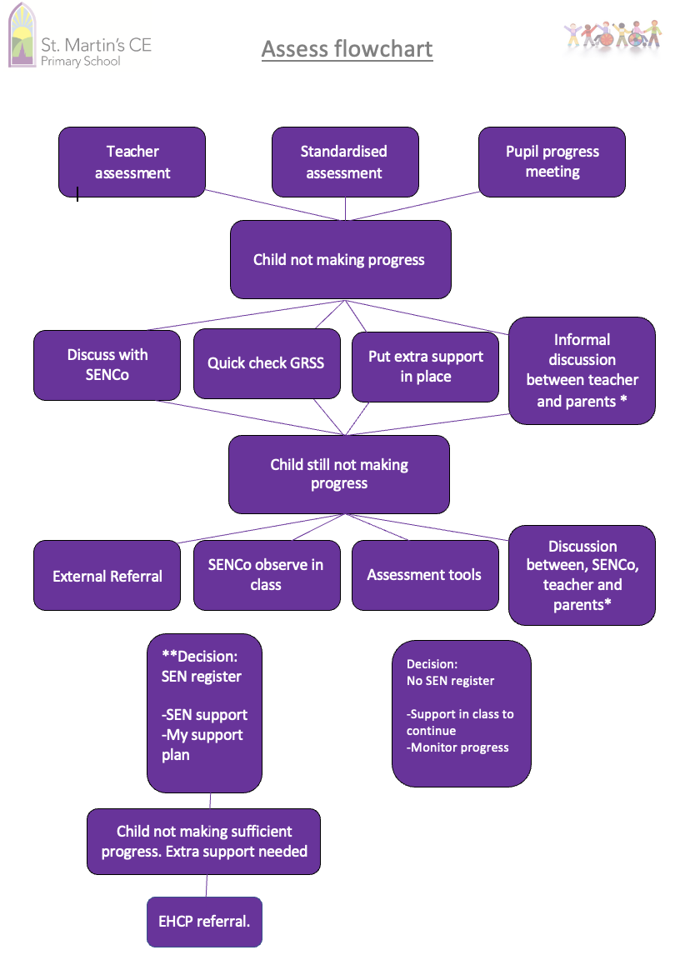

How do we work with others, including parents and children
It is important that decisions are not made in isolation and that we share information and collaborate to ensure the best SEND provision.

Parents and where appropriate, children, are included in meetings to discuss concerns, progress and to review success plans (three times a year). Parents are supported with formal processes such as EHCP applications or discussion with external advisors. The views of the child are included in all our assessments.

What is St Martin’s approach to teaching pupils with SEND?
All children have the right to a broad and balanced curriculum that is relevant and adapted, and which demonstrates progression and coherence. As such, the school is committed to identify and support all pupils who experience difficulties and, subject to the overall constraints of the school budget, provide such children with the levels of resources to meet their curricular needs.
We take a person-centred approach to meet individual needs. We may use a wide range of different strategies and adaptations to maximise progress. This may involve adapting learning activities, providing different resources, including teaching support.
We adopt a Plan - Do – Review approach. Teachers plan for individual children alongside group planning, deliver in an inclusive environment and set new targets in response to learning.

The graduated approach is a 4-part cycle of assess, plan, do, review.
Review
We will assess how well the support we put in place helped the child to meet the outcomes we set. We will use our improved understanding of
your child’s needs to improve the support we offer.
Assess
If your child is not making the expected level of progress, we will make an assessment to find out what strengths and difficulties your child has. We will ask for input from you and your child, as well as getting help from external professionals where necessary.

Plan
In discussion with you and your child, we will decide what outcomes we are hoping to achieve. We will make a plan of the support we will offer your child to help them meet those outcomes. We will make a record of this and share it with you and all relevant school staff.
Do
We will put our plan into practice.
The class teacher, with the support of the SENCO, will be responsible for working with your child on a daily basis, and making sure the support we put in place is having the impact we intended.

How will teachers support my child day to day?
Learning is individual for every child at St Martin’s. Teachers make adaptations and adjustments everyday to support all children within the classroom. This may look different in each lesson and each classroom but may include strategies, such as:

In addition, the school runs a number of interventions, which this year have included:
- Phonics catch up
- ELS Essentials reading scheme
- NELi Language scheme
- Bespoke maths, reading and writing interventions
Pupils with SEND may also be eligible for access arrangements in tests, such as Key Stage 2 SATS.

How do we monitor the progress of pupils with SEND?
Once a child has been assessed as a child with SEN or a disability, and is failing to make progress in at least one of the four areas of SEN, teachers set up a learning plan, which focuses on the child’s primary need.
We gain the views of parents and pupils to complete a pupil profile. This plan is intended to ensure long term outcomes are achievable through achievable shorter-term targets. The plans are reviewed termly in collaboration with parents and pupils.
Progress towards these targets is monitored by the class teacher, SENCo and Senior Leadership Team (SLT).
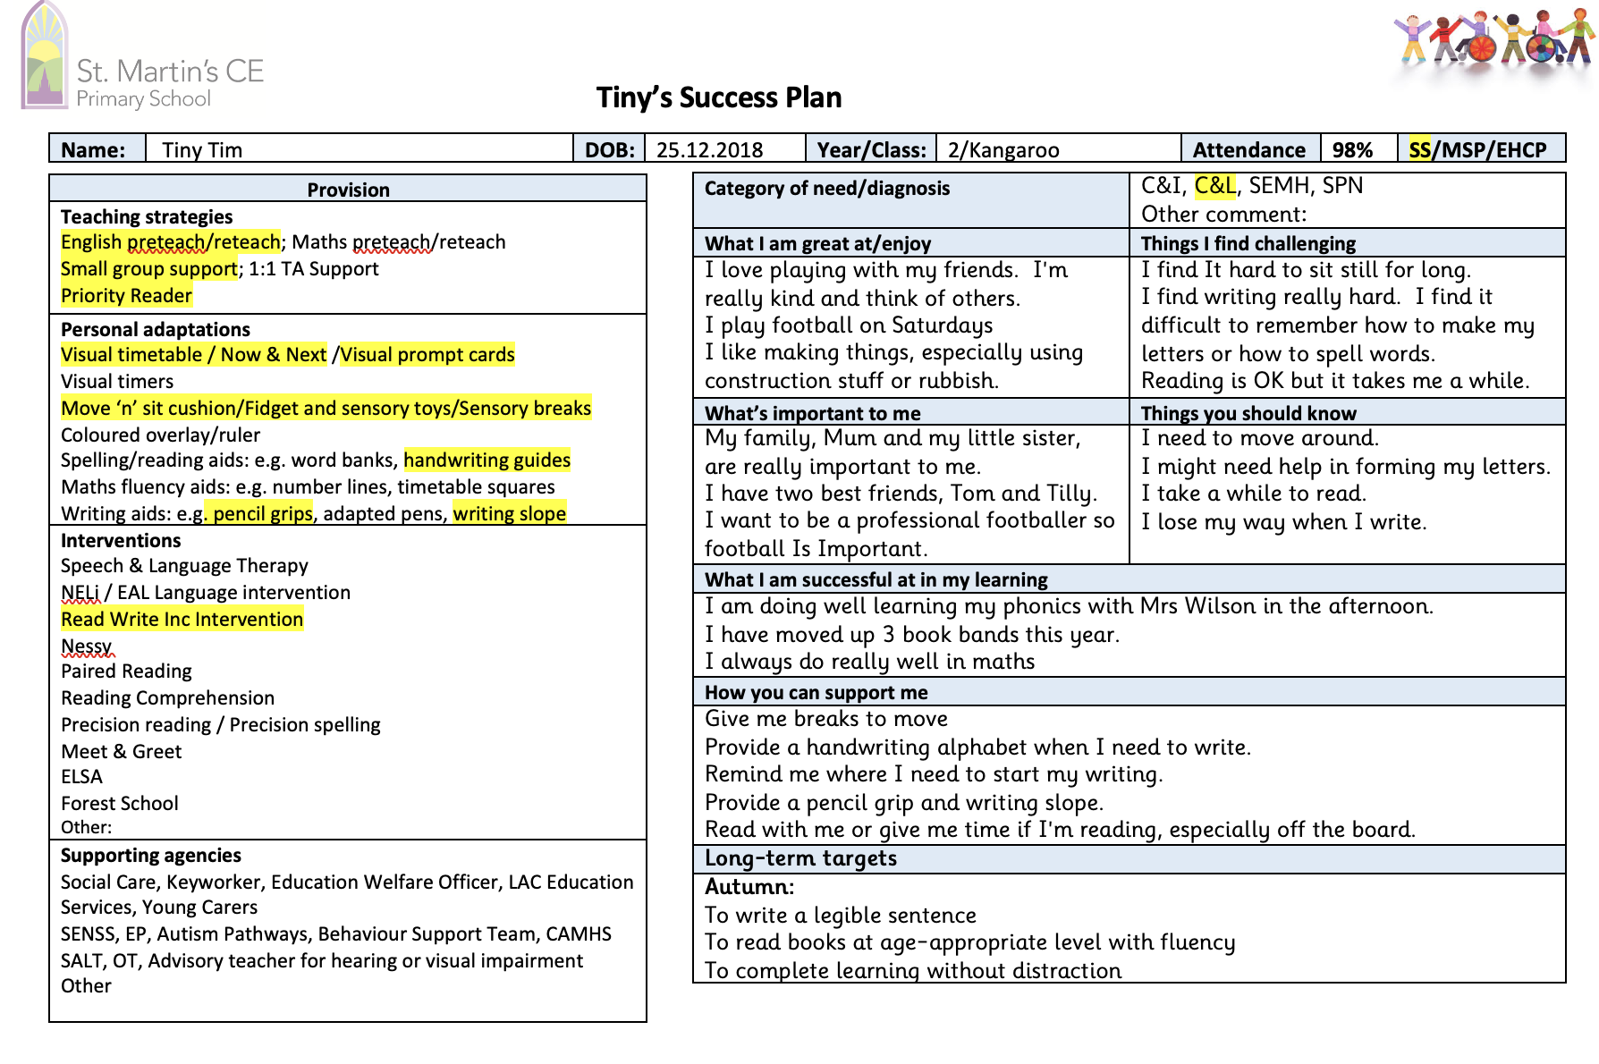

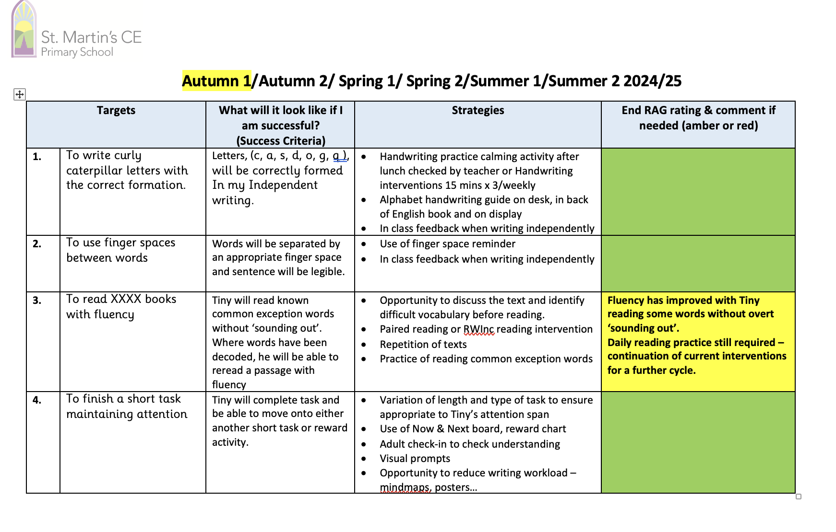

Education and Health Care Plan (EHCP)
A child who requires specific support in class and where progress and needs have not been met through a learning plan (as above) will be considered for an EHCP. The EHCP assessment is put forward to the SEND panel to be considered for an EHCP. A child at this level will be allocated a SEND Lead Worker through Wiltshire Council SEND Service. Parents, the child, school and any other agencies involved will be asked for their input which will be presented to the Wiltshire Council SEND panel. Further information is available in our SEND Policy.

In 2024/25, all pupils with SEN have an appropriate learning plan, which has been reviewed at the key assessment dates, alongside parents and pupils, and based on assessment, have benefited from new targets where appropriate.

How are children with SEND involved when we plan support?
As the child is at the heart of our decision making and the support we provide, it is important that we get to know them as individuals. We discuss their interests and strengths, and what they find difficult and what they feel helps them. This is captured on their individual learning plan or within EHCP applications.
In addition, periodically we survey pupils with SEND or other characteristics to gauge their opinions, for instance on their enjoyment of school, their views on learning and other aspects which might impact on their progress.

How are parents involved in decisions made about a child’s education
As well as providing twice yearly reports to all parents, classteachers will meet three times a year to:
- Set clear outcomes for your child’s progress,
- Review progress towards those outcomes,
- Discuss the support we will put in place to help your child make that progress.
The SENCo may attend these meetings to provide additional support.
We know that you are the expert when it comes to your child’s needs and aspirations so it is important for us that you fully understand how we are trying to meet your child’s needs and to ensure you tell us what you think would work best. We also need to know how your child’s need is impacting your child outside of school and how you cope with their needs.
If you have any concerns between reviews, please contact your child’s class teacher in the first instance. This may be at the school gate or you can make contact through the school office: 01722 554300 or admin@stmartins.dsat.org.uk
The SENCo will work closely with parents and teachers in preparation for an EHCP application, a referral for addition support form an external organisation or to inform a needs led approach to supporting a child.

How do we support pupils with transition from nursery and to secondary school?
Pupils entering from nursery with an existing SEN need will be supported by an enhanced transition. This will usually involve a meeting between the parents, nursery SENCo the school SENCo and possibly the local authority EYFS Inclusion Lead. This will be an opportunity to share information, strategies and adaptations. The child will be supported to access stay and play sessions in school prior to starting in September. Where a child already has an EHCP, the local authority will consult with school to see if the school can meet the child’s needs.

For Year 6 pupils with SEN, secondary schools will be advised of SEND needs and additional support required. For pupils with EHCPs, the school will complete a special EHCP review in Year 5, which will help to identify the most suitable secondary school, and ensure parent and pupil are able to contribute their preferences. The local authority will consult with the secondary school to ensure the child’s needs can be met. An enhanced transition is then offered.

How do we support pupils joining us from another school?
The school has a set procedure to support pupils and parents, which starts with visiting the school and meeting Senior Leadership Team. A checklist ensures that parents and pupils are guided through the induction process and the school has the information needed to inform how we support a child. Where a child already has an EHCP, we will be consulted by the local authority to ensure we can meet the child’s needs effectively.

Who helps in providing support for our pupils with SEND?

How do we ensure staff have the necessary expertise and training?
All staff receive ongoing Career Professional Development (CPD). This may take place on a whole school training day, a twilight session or in other meetings. Some staff will have bespoke training to support their role.

Examples of training content in 2024/25 includes:
- Creating successful individual learning plans
- Best practice for teaching assistants
- Classroom strategies for supporting learners with SEND
- ELSA training
- Speech & Language training
- Teamteach / supporting emotional dysregulation
- SENCo mentoring of teachers and TAs
- Educational Psychologist / Specialist SEN team guidance and feedback
- Training on phonics, reading and maths schemes including adaptation for SEND
- Training on supporting writing

How will the school support a child’s mental health and emotional and social development?
This year we provided the following support:
- 1:1 ELSA sessions to support individual needs
- Forest school
- Group ELSA interventions such as Zones of Regulation
- Group and individual sessions , such as Coping Cats, with Mental Health School Team (MHST, part of CAMHS)
- Play therapy on site for pupils based at local Refuge
- Pupils with SEN are encouraged to be a part of the School Council and undertake other class and school responsibilities.
- Meet & Greet is provided for a number of children with emotionally-based school avoidance, or who have difficult starts in the morning.

The school has a ‘zero tolerance’ approach to bullying. We recognise that pupils with differences are more likely to be bullied.
We prevent bullying in our school through the following strategies:
- We believe that responding to bullying should not start at the point at which a child has been bullied. We develop more sophisticated approaches in which Academy staff proactively gather intelligence about issues between pupils which might provoke conflict and develop strategies to prevent bullying occurring in the first place.
- St Martin’s follow a comprehensive PSHE and Relationships curriculum which involves developing an understanding of difference, promotes developing healthy relationships, mental health, British Values and children’s skills in being able to voice concerns.
We use dedicated days, events or projects and assemblies to recognise and support issues and differences.
- Staff themselves, in consultation with SLT, will be able to determine what will work best for their pupils, depending on the particular issues they need to address.
- We create an ethos of good behaviour where pupils treat one another and the staff with respect because they know that this is the right way to behave. Values of respect for staff and other pupils, an understanding of the value of education, and a clear understanding of how our actions affect others, permeate the whole Academy environment and are reinforced by staff and older pupils who set a good example to the rest. Staff also receive training to provide a consistent approach.

What do you do if bullying has taken place
Prevention
- We believe that responding to bullying should not start at the point at which a child has been bullied. We develop more sophisticated approaches in which Academy staff proactively gather intelligence about issues between pupils which might provoke conflict and develop strategies to prevent bullying occurring in the first place.
- All Academies follow a comprehensive PSHE and Relationships curriculum which involves developing an understanding of difference, promotes developing healthy relationships, mental health, British Values and children’s skills in being able to voice concerns.
Academies may further support and highlight issues through dedicated days, events or projects, or through assemblies.
- Staff themselves, in consultation with SLT, will be able to determine what will work best for their pupils, depending on the particular issues they need to address.
- We create an ethos of good behaviour where pupils treat one another and the Academy staff with respect because they know that this is the right way to behave. Values of respect for staff and other pupils, an understanding of the value of education, and a clear understanding of how our actions affect others, permeate the whole Academy environment and are reinforced by staff and older pupils who set a good example to the rest.
The school’s governors monitor and evaluate how effectively the school is dealing with bullying, with regard to its Anti-bullying Policy. The policy is available here.

How does the school support pupils with disabilities in the school environment?
Please read our Equality Policy for further information on how and when the school will make reasonable adjustments to support pupils with disabilities. Adjustments reflect the needs of an individual. At St Martin’s, auxiliary aids and services, may include additional or different resources in class, such as writing tools, reading overlays, assistive technology, or adapted seating. It may be useful to provide sensory breaks, additional adult support or adapted tasks to enable a child with disability to be successful.

Complaints
If someone has a complaint regarding the SEND process, Mrs Abbott would like the opportunity to discuss the matter first. However, if the complaint cannot be resolved with full agreement, Mrs Abbott will follow the Complaints Policy. To see the full explanation of suitable avenues for complaint, see pages 246 and 247 of the SEND Code of Practice.
If you feel that our school has discriminated against your child because of their SEN, you have the right to make a discrimination claim to the first-tier SEND tribunal. To find out how to make such a claim, you should visit: https://www.gov.uk/complain-about-school/disability-discrimination
You can make a claim about alleged discrimination regarding:
- Admission
- Exclusion
- Provision of education and associated services
- Making reasonable adjustments, including the provision of auxiliary aids and services
Before going to a SEND tribunal, you can go through processes called disagreement resolution or mediation, where you try to resolve your disagreement before it reaches the tribunal.
Contact details of the disagreement resolution and mediation services for Wiltshire Council is provided on the Wiltshire Local Offer website

Links

- http://www.wiltshire.gov.uk/local-offer
- http://www.autismeducationtrust.org.uk
- http://www.anti-bullyingalliance.org.uk

