
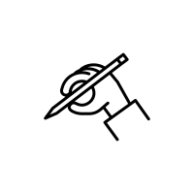
Handwriting curriculum at St. Martin’s
Letter formation and handwriting progression

Handwriting:
At St. Martin’s we build solid foundations in letter formation through our systematic, synthetics phonics teaching programme, Essential Letters and Sounds. This supports children to become accurate, fluent writers using mnemonics to help children visualise the letter or join before they write it. We recognise that children need to practise handwriting under the guidance of an adult to ensure accuracy and avoid habits which will be difficult to undo later. Explicit live modelling is crucial using resources including but not limited to the visualiser, writing repeater and flipcharts.

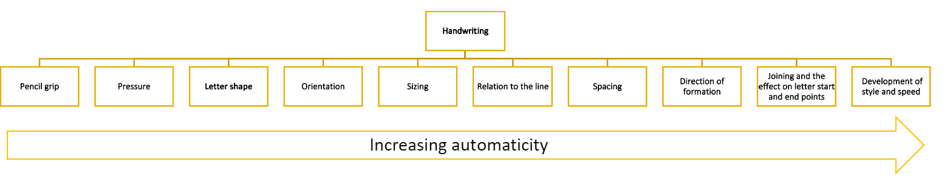

Children are expected and held account for accurate letter formation, including size, orientation and relationship to the line. Once accuracy is achieved, children are taught to become faster fluent writers through considering their sizing and orientation before learning how to accurately join and write at speed legibly.

 | EY pre-writing | EY - handwriting | Year 1 | Year 2 | Year 3 | Year 4 | Year 5 | Year 6
Handwriting | Pencil control concepts  - Stages of motor learning  - Thinking about it (cognitive stage)  - Practising it (associative stage)  - Doing it automatically (autonomous stage)  - Motor learning includes:  - Shape formation  - Directionality  - Fluidity of movement  - Pressure control  - Fine motor skills  - Pencil grip  To assist in readiness for handwriting, we ensure that children make progress through the developmental continuums for: fine motor skills / scissor skills / pre-writing skills (which includes hand preference).  Pre-Writing Strokes (Large Motor → Small Motor)  Teach in this order:  Vertical lines  Horizontal lines  Circles  Crosses  Diagonals  Curves  Zigzags  Use sky-writing, air-tracing, sand trays, and large surface work before paper.  Mastery Indicators  ✔ Draws lines without lifting  ✔ Controls direction  ✔ Understands top-to-bottom progression  Fine motor skills  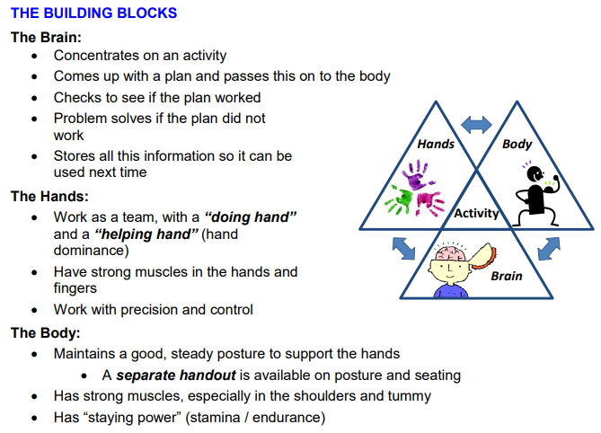  These include:  - Strengthening work  - Skill building activities  - Speed work  Children should be secure with these individual strokes before putting the strokes together to form individual graphemes.  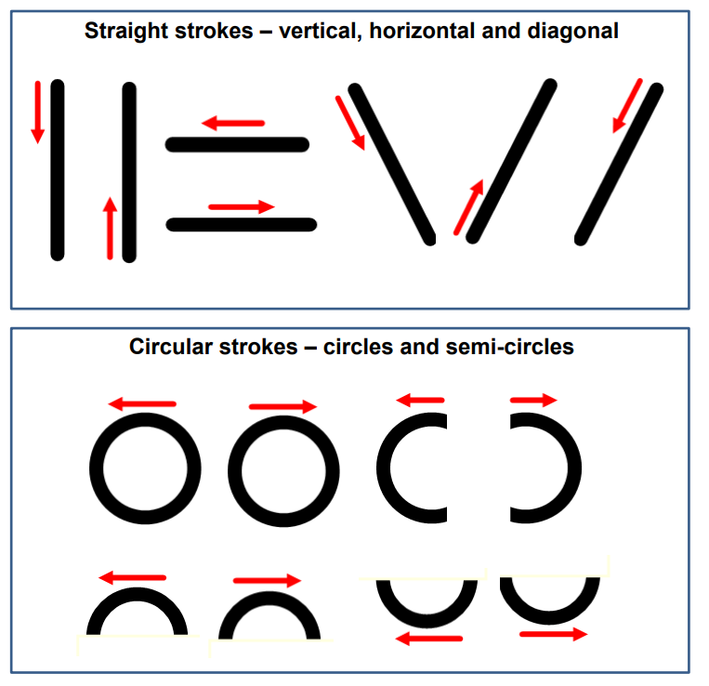 | Explicit handwriting instruction is built on children’s early movement and coordination skills, and their security in the pencil control concepts of shape formation, shape manipulation, directionality, fluidity of movement, fine motor skills, pressure control and pencil grip.  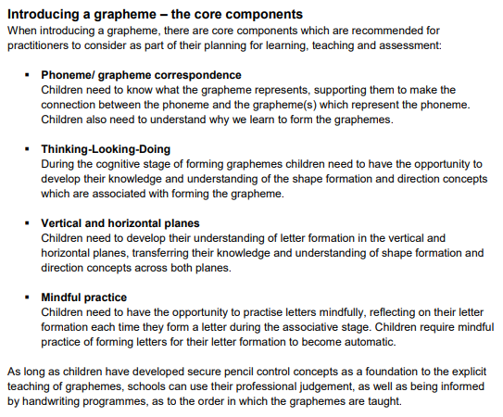  Know the handwriting position:  - Feet flat on the floor  - Bottom at the back of the chair  - Body one fist from the table  - Shoulders down and relaxed  - Back leaning forward slightly  - Non-writing hand holding the page  - Writing hand ready in tripod grip  - Elbow support to prevent sloping.  Form all lower-case letters of the alphabet accurately on plain paper.  Curly Letters  (Anti-clockwise family – teach first)  Letters:  a, c, e, o, g, s, q, d, f  a – “Around the head, down the body.”  c – “Curl around the camel's back.”  e – “Around the head and down the trunk”  o – “Around the ostrich's body.”  g – “Around her face, down the beard.”  s – “Swerve around the snake”  d – “Around his body, up tall.”  q – “Around the feather and down the pen.”  d – “Over his back and around the tail, up his neck and down to his feet.”  f – “Over the ear, down to the tail and across the jaw.”  Why first?  The anti-clockwise motion is foundational to fluent handwriting.  Mastery Indicators:  Starts at the correct point  Moves anti-clockwise  Closes letters properly  Ladder Letters  Letters:  l, i, t, j, u, y  Rhymes:  i – “Down her body, dot her idea.”  l – “Down the long ladder.”  t – “Down the tower, cross.”  u – “Under the umbrella and down to the tip.”  j – “Under the hull and down to the anchor.”  y – “Down the tongue, up the tongue.”  Focus:  Top-to-bottom formation  Correct dotting and crossing  Straight, controlled down strokes  One-Arm Robot Letters  Letters:  p, m, r, h, n, b, k  Rhymes:  p – “Down his body, around his face.”  m – “Meerkat, mound, mound.”  r – “Down her body, up over her arm.”  h – “Down her body and over her arm.”  n – “Down the bird and over the nest.”  b – “Down his body, around his face.”  k – “Down the body, up the arm, down the leg.”  Zigzag Letters  Letters:  v, w, x, z  Rhymes:  v – “Down the tongue, up the tongue.”  w – “Hop to the top, land and hop, land and hop.”  x – “Criss-cross the kiss.”  z – “Zig and zag.”  Learn all placement on the writing line  X-Height (Short Letters)  a, c, e, i, m, n, o, r, s, u, v, w, x, z  Ascenders  b, d, h, k, l, t, f  Descenders  g, j, p, q, y  To write (form letters correctly) in a range of writing contexts, so not just when writing in handwriting and phonics lessons.  To apply correct letter formation of all letters. | - sit correctly at a table, holding a pencil comfortably and correctly  - form lower-case letters in the correct direction, starting and finishing in the right place  - form capital letters  - form digits 0-9  - understand which letters belong to which handwriting ‘families’ (i.e. letters that are formed in similar ways) and to practise these.  - Know all placement on the writing line | - form lower-case letters of the correct size relative to one another  - know the diagonal joins  - Know the 3 horizontal strokes  - Know which letters, when adjacent to one another, are best left un-joined.  - write capital letters and digits of the correct size, orientation and relationship to one another and to lower-case letters  - use spacing between words that reflects the size of the letters | - use the diagonal and horizontal strokes that are needed to join letters and understand which letters, when adjacent to one another, are best left un-joined  - increase the legibility, consistency and quality of their handwriting, [for example, by ensuring that the down strokes of letters are parallel and equidistant, and that lines of writing are spaced sufficiently so that the ascenders and descenders of letters do not touch] |  | - write legibly, fluently and with increasing speed by:  - choosing which shape of a letter to use when given choices and deciding whether or not to join specific letters  - choosing the writing implement that is best suited for a task

Teaching of handwriting
EY: careful planning underpins both the teaching, deliberate practice of and further, more autonomous practise in pre-writing strength, skills and speed build up. These add to and unite with letter formation learning. Letter formation and effective handwriting skills are taught, practised and errors remediated as part of the daily phonics sessions and through additional adult supervised provision. Those children needing more adult guidance and/or practice, get it.

Y1: Letter formation and effective handwriting skills are taught, practised and errors remediated as part of the daily phonics sessions and through additional adult supervised provision. Those children needing more adult guidance and/or practise, get it. The build-up of writing in English lessons, is small step, so children have further opportunities to become accurate and fluent in both letter formation and handwriting skills. Letter joins will be introduced from Year 2 upwards

Y2: Letter formation and effective handwriting skills are taught, practised and errors remediated as part of the daily handwriting sessions. The build-up of writing in English lessons, is small step, so children have progressive opportunities to apply fluency in handwriting, so that they gain an effective and automatic script. Letter joins are introduced from Term 4.

KS2: Handwriting is taught, practised and errors remediated as part of the writing lesson in KS2. Teachers consciously consider their handwriting during model write sessions. Pupils are held to account for the quality of their handwriting script. In Y3, handwriting continues to be taught whole class to embed fluency.

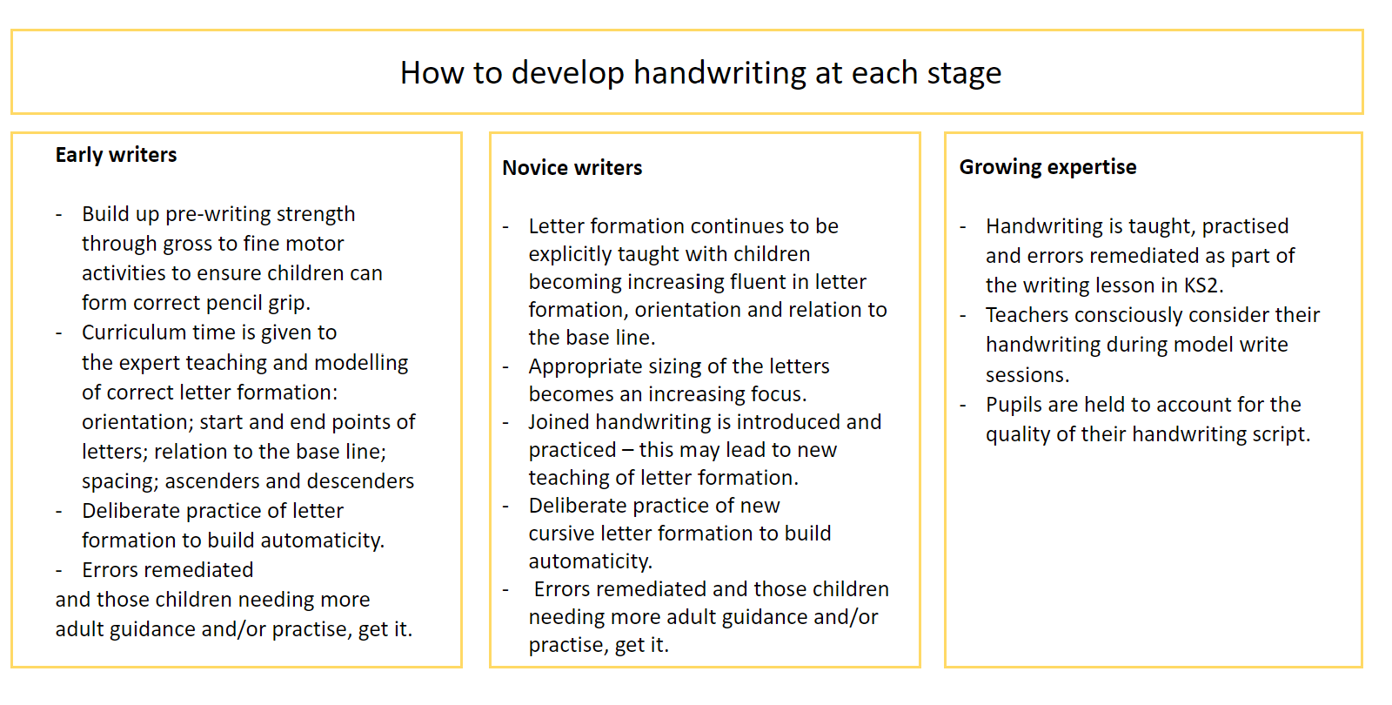

Metacognition in handwriting
Children are enabled at all levels to be metacognitive during handwriting tasks, planning their approach through visual cues followed by monitoring and evaluating their handwriting. Example of metacognitive questions they might consider are:

- How would you rate your handwriting here?
- Circle your best word for me ..
- Can any letters be improved?
- Are your letters the right size?
- Are they sat on the line?
- Are your ascenders / descenders the same length?
- Where is it best to start writing this letter?
- What letter/s have you made the most clear?
- Are letters consistent in their sizing?

Early Years – Early writers
In the Autumn term of the Reception year, the children begin daily phonics and handwriting sessions. Children rapidly learn sounds and the letters that they need to represent them when they begin on the ELS Phonics scheme. Simple and enjoyable mnemonics help all children to grasp the letter sound correspondences quickly, especially those who are at risk of making slower progress or those who are new to learning English. Once children have been introduced to a new sound, they will be taught how to form the letter/s. The teacher begins by air-writing the letter shape/s and the children copy this. The next step is to model writing the letter on the board and referring to the handwriting phrase. Children then practise writing their own letter whilst repeating the phrase to themselves. They should be encouraged to write the letter numerous times. The children will be given the opportunity to write previously learnt sounds without the teacher modelling them first. Children will be given a sheet containing the focus sound where they can practise reading and writing this at home. We make the physical process of writing – handwriting – enjoyable from the start, so children see themselves as ‘writers’.
Where should children sit to write?
Children should be sat at a table. Writing on lined paper with pencils is encouraged (rather than whiteboards and pens).
The correct position in all year groups should be:
- Put two feet on the floor
- Push their bottom to the back of their chair
- Tuck their chair under the table
- Hold their pencil in a tripod grip
- Place their other hand on their book or paper, so it doesn’t move around. This requires repeated regular prompts in all year groups.

Right- Handed Pupils
- Right - handed Children should have their writing material tilted slightly to the right with the top right-handed corned raised slightly.
Left- Handed Pupils
- Left- handed children are encouraged to find a comfortable orientation for their paper, usually slightly to the left of centre of their body.
- Teachers are alert to the fact that it is very difficult for left-handed pupils to follow handwriting movements when they are modelled by a right-handed teacher
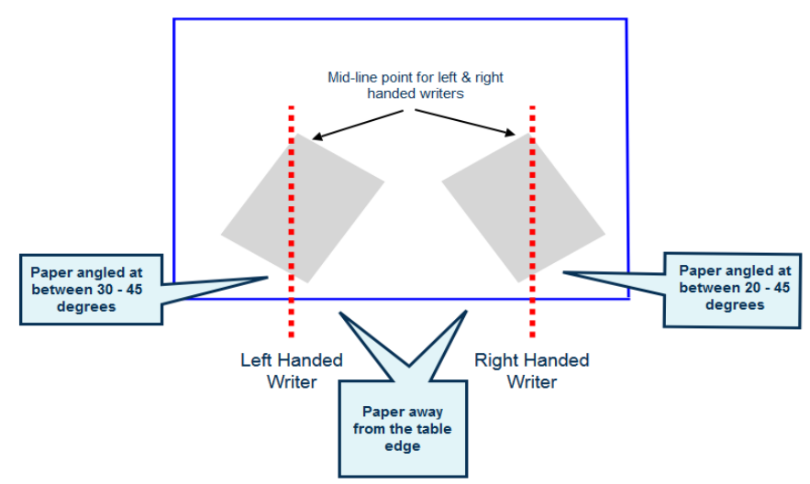

Pencil grip
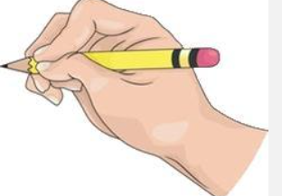
Teachers understand the typical development of a correct pencil grip with the aim that all children will have developed a tripod grip by Year 1. We recognise that a small number of children may need additional support to develop a tripod grip. Pencil grip correctors are often used in these cases as an aid to develop the muscle memory required to maintain an efficient pencil hold.
Once children can form the letters correctly, they learn how to place the letters on the line and of relative size.

Year group handwriting overview: -

Reception – Stage 1 a/b (Red, Green, Purple, Pink, and Orange Storybooks.)

Autumn 1 | Autumn 2 | Spring 1 | Spring 2 | Summer 1 | Summer 2
 | The children will revisit:  • c a o d g q  • l t b p k h I j m n r u k  • e f s  • v w x z  (Note: letters and with similar movements are grouped together. The similarities should be discussed with the children.) | Handwriting - where to put letters on the writing line.  Developing an awareness of sizing.  The children will revisit letter formation but this term the focus will be on the relative sizing of the letters.  Wk 1  a c e i m  Wk 2  n o r s u  Wk 3  v w x z  Wk 4  g j p q y  Wk 5 and 6  b d h k l t f | Handwriting – correct formation and where the letter sits on the writing line  Increasing control over sizing with lower-case letters of the correct size relative to one another  The children will revisit letter formation but this term the focus will be on increasing control and consistency over sizing of the letters and positioning on the line.  Wk 1 and 2  c a o d g q  Wk 3 and 4 and 5  l t b p k h i j m n r u k  Wk 6  v w x z | Handwriting – correct formation and where the letter sits on the writing line  Increasing control over sizing with lower-case letters of the correct size relative to one another  The children will revisit letter formation but this term the focus will be on combining letter shapes  Wk 1-6  c a o d g q  l t b p k h i j m n r u k | Handwriting – correct formation and where the letter sits on the writing line  Increasing control over sizing with lower-case letters of the correct size relative to one another  Tripod pencil grip established  The children will revisit letter formation but this term the focus will be on combining letter shapes,  embedding correct formation, positioning on the line and sizing leading to automaticity.  Wk 1 – 3  • e f s  • l t b p k h I j m n r u k (down letters)  Wk 3 – 6  • e f s  • c a o d g q
  m, a, s, d, t
  i, n, p, g, o
  c. k. u. b
  f, e, l, h, sh
  r, j, v y, w
  th, z, ch, qu, x, ng, nk
  m, a, s, d, t
  i, n, p, g, o
  c. k. u. b
  f, e, l, h, sh
  r, j, v y, w
  th, z, ch, qu, x, ng, nk

Sample words for teaching handwriting

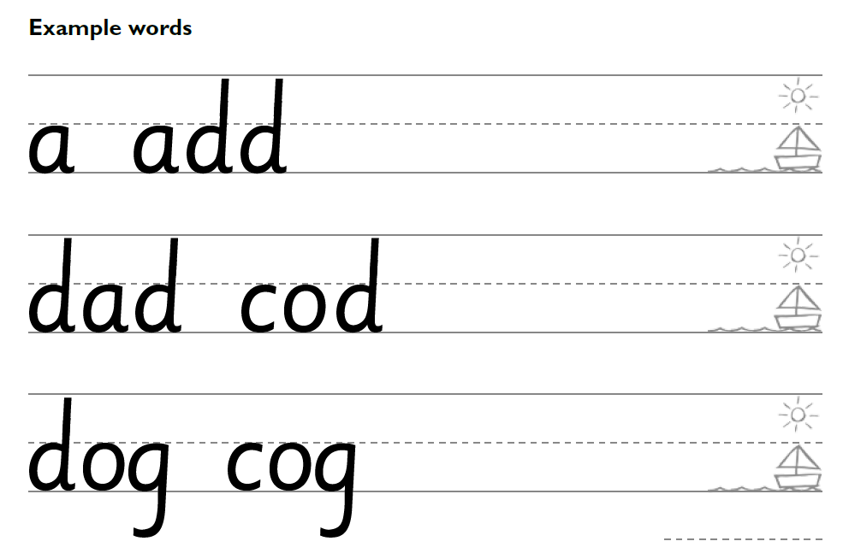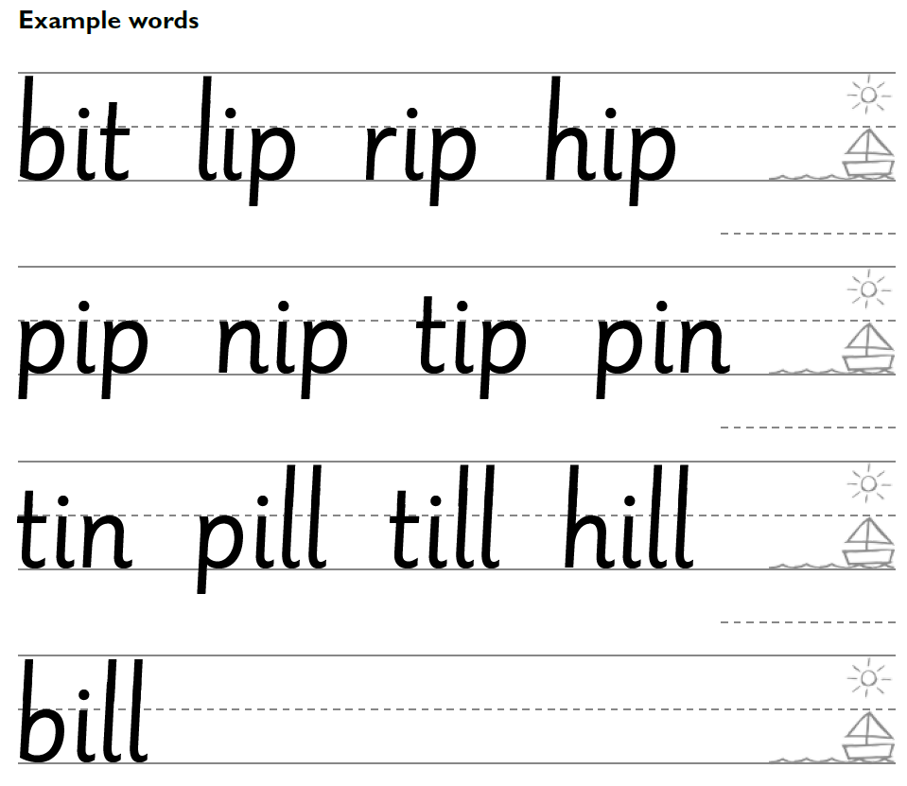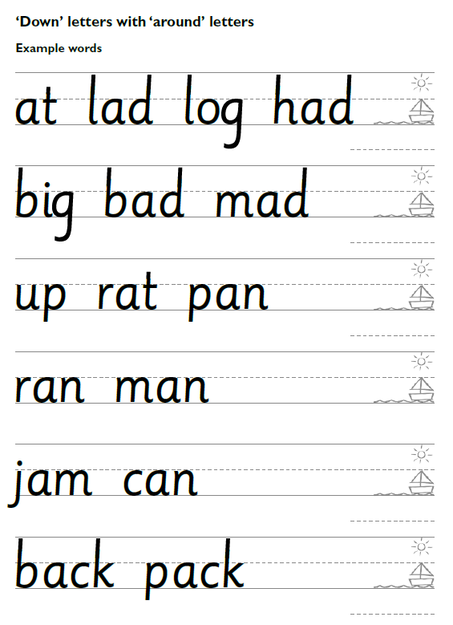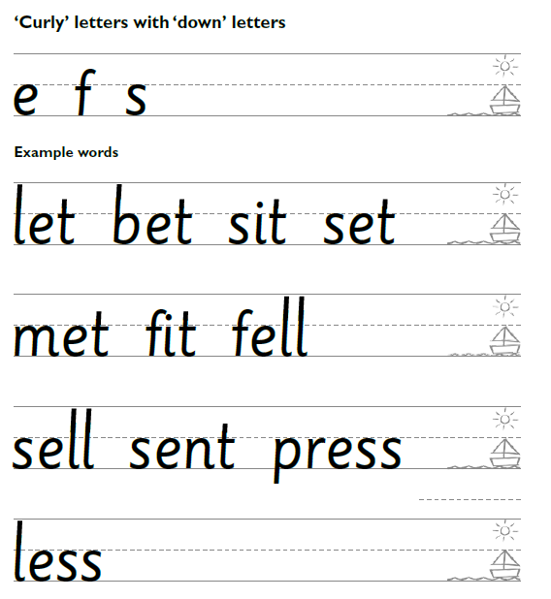

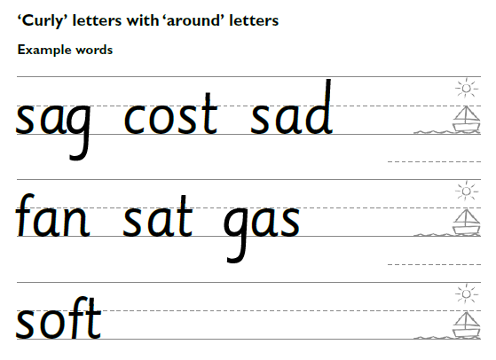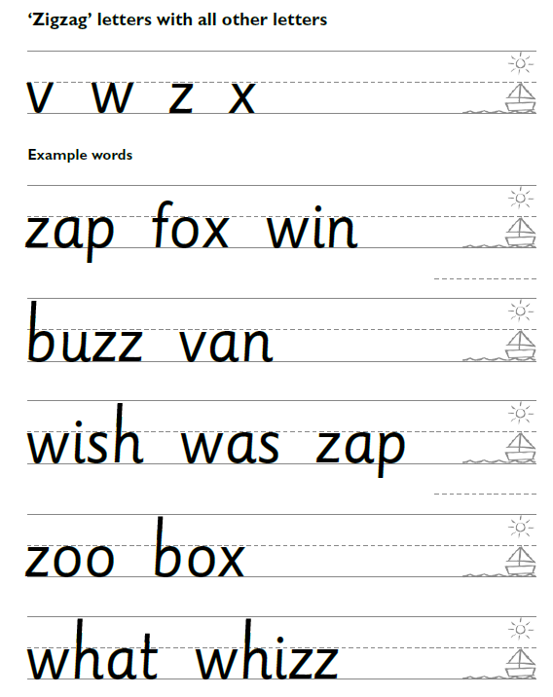

Year 1
How should children sit?

Children sit at tables for the whole of the lesson. You will need to arrange tables and chairs so all children can clearly see the whiteboard. Place children in partners side-by-side; they check each other’s letters at key points in the lesson
1. Revisit letter and rhyme.
2. Show children how to write the letter.
Partner check
3. Children practise writing the letter.
4. Children check their letters with their partner.
5. Repeat steps 2, 3 and 4.
6. Review the new letter and previous letters by asking children to practise writing words containing them. While your children are writing, support children who need extra help.
Partner Check

Year 1

Autumn 1 | Autumn 2 | Spring 1 | Spring 2 | Summer 1 | Summer 2
Form lower-case letters of the correct size relative to one another  Revisit all 4 letter families and their rhymes  Curly Letters  Letters:  a, c, e, o, g, s, q, d, f  a – “Around the head, down the body.”  c – “Curl around the camel's back.”  e – “Around the head and down the trunk”  o – “Around the ostrich's body.”  g – “Around her face, down the beard.”  s – “Swerve around the snake”  d – “Around his body, up tall.”  q – “Around the feather and down the pen.”  d – “Over his back and around the tail, up his neck and down to his feet.”  f – “Over the ear, down to the tail and across the jaw.”  Ladder Letters  Letters:  l, i, t, j, u, y  Rhymes:  i – “Down her body, dot her idea.”  l – “Down the long ladder.”  t – “Down the tower, cross.”  u – “Under the umbrella and down to the tip.”  j – “Under the hull and down to the anchor.”  y – “Down the tongue, up the tongue.”  One-Arm Robot Letters  Letters:  p, m, r, h, n, b, k  Rhymes:  p – “Down his body, around his face.”  m – “Meerkat, mound, mound.”  r – “Down her body, up over her arm.”  h – “Down her body and over her arm.”  n – “Down the bird and over the nest.”  b – “Down his body, around his face.”  k – “Down the body, up the arm, down the leg.”  Zigzag Letters  Letters:  v, w, x, z  Rhymes:  v – “Down the tongue, up the tongue.”  w – “Hop to the top, land and hop, land and hop.”  x – “Criss-cross the kiss.”  z – “Zig and zag.” | Form lower-case letters of the correct size relative to one another  Know where to place the letters on the writing line  These letters sit between the baseline and the middle line only.  Letters:  a, c, e, i, m, n, o, r, s, u, v, w, x, z  - x-height letters  - Sometimes called short letters  These letters go below the baseline.  Letters:  g, j, p, q, y  Correct term:  - descenders  - letters with a descender  These letters go above the x-height to the top line.  Letters:  b, d, h, k, l, t, f  - ascenders  - Letters with an ascender  To apply correct letter formation of all letters. | Write capital letters of the correct size, orientation and relationship to one another and to lower-case letters  Teach capital letters  WK1  A-E  WK 2  I-J  WK 3  K-O  WK 4  P-T  Wk 5  U-Y  WK6  Z and recap of tricky ones. | Write capital letters and digits of the correct size, orientation and relationship to one another and to lower-case letters  The children will practise combining capital starting letters followed by lower- case letters using sample words  WK 1 and 2  c a o d g q  WK 3 and 4 and 5  l t b p k h I j m n r u k  WK 6  v w x z | Sample word application  revisit deficits within cohort, or revisit cycle again | Sample word application  revisit deficits within cohort, or revisit cycle again

Year 2
It is not a statutory requirement of the 2014 National Curriculum that children use joined-up handwriting until Year 3, although it notes that children ‘should be taught to write with a joined style as soon as they can form letters securely with the correct orientation’.

Handwriting will also be linked to spelling patterns.
In Year 2 at St. Martin’s, children will be taught to join most letters by the end of the year.
Joins
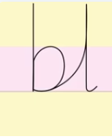
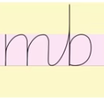
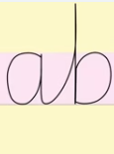
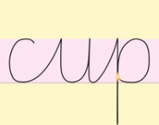
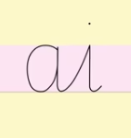
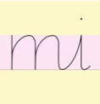
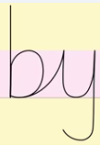

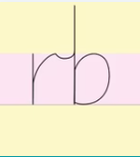
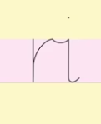
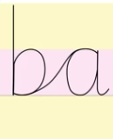
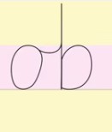
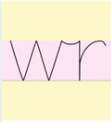
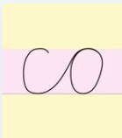


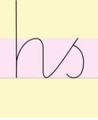
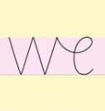
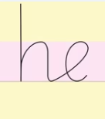
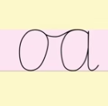
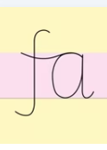

Year 2

Autumn 1 | Autumn 2 | Spring 1 | Spring 2 | Summer 1 | Summer 2
Know where to place the letters on the writing line  These letters sit between the baseline and the middle line only.  Letters:  a, c, e, i, m, n, o, r, s, u, v, w, x, z  - x-height letters  - Sometimes called short letters  These letters go below the baseline.  Letters:  g, j, p, q, y  Correct term:  - descenders  - letters with a descender  These letters go above the x-height to the top line.  Letters:  b, d, h, k, l, t, f  - ascenders  - Letters with an ascender  To apply correct letter formation of all letters. | Continuous afl and provision based on cohort needs and individual needs before progressing on to joins | Continuous afl and provision based on cohort needs and individual needs before progressing on to joins | Week 1 – Curly & Ladder Letter Joins  Lesson 1: ai, du, cr  → Curly letter joins (c, a, d, g, o, q family)  Lesson 2: mi, nu, hi  → Ladder letter joins (i, l, t, u, y family)  Lesson 3: by, pr, uv  → Descender joins (g, j, p, q, y family)  Lesson 4: cup, tip, tum, nip, lip  → Applying joins in short CVC words  Week 2 – Bridge & Arch Joins  Lesson 1: ab, cl, ch  → Over-curve (bridge) joins  Lesson 2: mb, nk, th  → Double arch & tall letter joins  Lesson 3: bl, ph, ib  → Tall-to-short letter joins  Lesson 4: kit, bull, bulb, nutty, tilt  → Fluency in simple words  Week 3 – Round Letter Joins  Lesson 1: co, dg, da  → Round-to-stem joins  Lesson 2: ma, no, nd  → Arch-to-round joins  Lesson 3: ba, pa, ka  → Anti-clockwise entry joins  Lesson 4: dad, dig, add, can, back  → Application and consistency  Weeks 4–6 – Review & Reinforcement  Letter families revision  Consistent size and orientation  Clear ascenders and descenders  Spacing between words | Week 1 – Vowel & Special Joins  Lesson 1: oi, or, ow  → Diagonal joins to round letters  Lesson 2: wr, vu, fn  → Irregular joins & control practice  Lesson 3: ri, ry, rr  → Repeated letter joins  Lesson 4: fur, own, ring, warm, fruit  → Applying joins in longer words  Week 2 – Horizontal Joins  Lesson 1: ob, oh, ot  → Horizontal joins to tall letters  Lesson 2: wh, xt, wl  → Crossing & extended joins  Lesson 3: rb, fl, rh  → Loop and flick joins  Lesson 4: owl, flap, whirl, vivid  → Fluency and rhythm  Week 3 – Flow & Fluency  Lesson 1: va, wa, wo  → Diagonal joins to w & v  Lesson 2: fa, ro, ra  → Tall-to-round joins  Lesson 3: oa, oo, og  → Vowel pattern joins  Lesson 4: frog, word, food, world  → Speed with legibility  Weeks 4–6 – Consolidation  Consistent slant  Even letter size  Clear joins  Writing simple sentences fluently | Week 1 – High Frequency Joins  Lesson 1: he, ee, de  Lesson 2: we, re, fe  Lesson 3: love, meet, cute, even, here  Week 2 – S-Based Joins  Lesson 1: hs, os, rs  Lesson 2: sw, so, se  Lesson 3: mess, most, easy, shop, does  Weeks 3–6 – Review & Mastery  Sentence writing  Spacing accuracy  Presentation skills  Writing across the curriculum

Inclusion
Most children will be able to write fluently and legibly. However, some children may need additional support to develop a fluent, legible style of handwriting. Provision will be made through additional sessions once whole class teaching has finished at the end of Y3 that are focused on the child’s identified specific difficulty with handwriting. Teachers who are concerned about a child’s progress in handwriting will seek advice from our school’s SENDCo.
By the end of Year 2, we expect that children can write legibly, and neatly with a consistently high standard of presentation, but we will continue to practise handwriting in Y3 to ensure that it is embedded.
By this stage we aim for the children to:
• sir correctly at a table, holding a pencil comfortably and correctly.
• use the diagonal and horizontal strokes that are needed to join letters and understand which letters, when adjacent to one another, are best left unjoined.
• increase the legibility, consistency and quality of their handwriting (for example, by ensuring that the downstrokes of letters are parallel and equidistant; that lines of writing are spaced sufficiently so that the ascenders and descenders of letters do not touch)
• increase the fluency with which they can write what they say



